CmpE 110 LAB5 Dr. Ahmet Bindal

Part 1: Design a 3-bit flash Analog-to-Digital Converter (ADC)

Using the circuit schematic below, apply 5V to each operational amplifier from the LTSPICE digital library (with +5V and 0V power supplies) and to the vref terminal. Assume R = 10Kohms.

Increase analog voltage amplitude from 0V to 5V by 0.5V increments, and record the output values in each case. How does Out [7:0] relate to your analog input? Measure the quantization error at the input.

Implement the encoder circuit to obtain DOut [2:0], a 3-bit digital representation of Out [7:0]. For those of you who are not familiar to encoder design, please refer to the last chapter of your book about logic design circuits, consult with me or your teaching assistant.

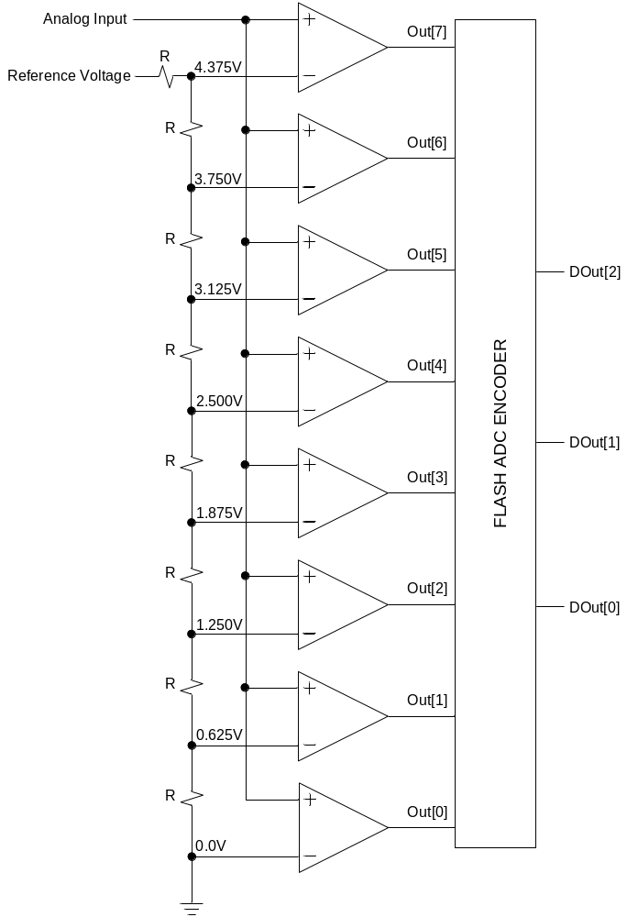

Part 2: Design a 3-bit Digital-to-Analog Converter (DAC)

Using operational amplifiers from the LTSPICE digital library (with +5V and 0V power supplies) and the circuit schematic below, apply +Vcc = +5V and -Vcc = 0V to the operational amplifier. Assume R = 10Kohms (if this value does not work, try increasing the resistance value).

Apply LOGIC 0 = 0V and LOGIC 1 = 5V to MSB, MID and LSB inputs as shown in the truth table. Measure the output voltage, vout, and the error between the expected output voltage and the experimental output value in each case. Explain the reason of error.

